WT Experiment 6

Topic: Wireless Temperature and Humidity Monitoring System

Class | Roll No. | Name
D15A | 10 | Chirag Choudhary
D15A | 19 | Manorath Ital

Aim:
Study of Ultrasonic Sensor and LCD interfacing with Arduino

1. Introduction

Distance measurement is an essential part of many embedded and automation systems such as robotic navigation, obstacle avoidance, and industrial safety. This project focuses on using an ultrasonic sensor (HC-SR04) to measure the distance of an object from the sensor and display the results in real time on a 16x2 I2C LCD display using an Arduino Uno. The sensor calculates the distance by measuring the time it takes for an ultrasonic pulse to travel to the object and back.

2. Materials and Components

Microcontroller: Arduino Uno

Sensor: HC-SR04 Ultrasonic Sensor

Display: 16x2 I2C LCD Module

Connecting Components:

Breadboard

Jumper Wires

Power Supply: USB Cable or 9V battery with adapter

3. System Architecture

The system consists of the following:

HC-SR04 Ultrasonic sensor to measure distance based on the time-of-flight of ultrasonic waves.

Arduino Uno to trigger the sensor, read echo response, compute the distance and control LCD display.

16x2 I2C LCD display to show the measured distance in centimeters.

The LCD is connected to Arduino using I2C protocol to reduce wiring complexity and improve reliability.

4. Circuit Diagrams and Wiring
Ultrasonic Sensor (HC-SR04):
VCC → 5V
GND → GND
Trig → Digital Pin 3 on Arduino
Echo → Digital Pin 2 on Arduino
16x2 I2C LCD:
VCC → 5V
GND → GND
SDA → A4 (Arduino Uno)
SCL → A5 (Arduino Uno)

5. Software Implementation

Code:

#include <LiquidCrystal_I2C.h>

LiquidCrystal_I2C lcd(0x27, 16, 2); // Format -> (Address, Width, Height)

#define echoPin 2 // attach pin D2 Arduino to Echo pin of Sensor module

#define trigPin 3 // attach pin D3 Arduino to Trig pin of Sensor module

long duration; // Declare variable to store echo time duration

float distance; // Declare variable to store the result (distance) as a decimal

void setup()

{

lcd.init(); // Initialize the LCD

lcd.backlight(); // Turn on the backlight

pinMode(trigPin, OUTPUT); // Sets the trigPin as an OUTPUT

pinMode(echoPin, INPUT); // Sets the echoPin as an INPUT

// Serial Communication is starting with 9600 baudrate speed

Serial.begin(9600);

// The text to be printed in serial monitor

Serial.println("Distance measurement using Arduino Uno");

delay(500);

}

void loop()

{

digitalWrite(trigPin, LOW);

delayMicroseconds(2);

digitalWrite(trigPin, HIGH);

delayMicroseconds(10);

digitalWrite(trigPin, LOW);

duration = pulseIn(echoPin, HIGH);

distance = duration * 0.0344 / 2.0; // Ensure floating point division

// Print the result to the serial monitor

Serial.print("Distance: ");

Serial.print(distance, 2); // Print with 2 decimal places

Serial.println(" cm");

// Display the result on the LCD

lcd.clear(); // Clear the display buffer

lcd.setCursor(0, 0); // Set cursor for "Distance:" (Column, Row)

lcd.print("Distance:"); // Print "Distance:" at (0, 0)

lcd.setCursor(0, 1); // Set cursor for output value (0, 1)

lcd.print(distance, 2); // Print the distance with 2 decimal places

lcd.setCursor(8, 1); // Move cursor to (8, 1)

lcd.print("cm"); // Print "cm" at (8, 1)

delay(2000);

}

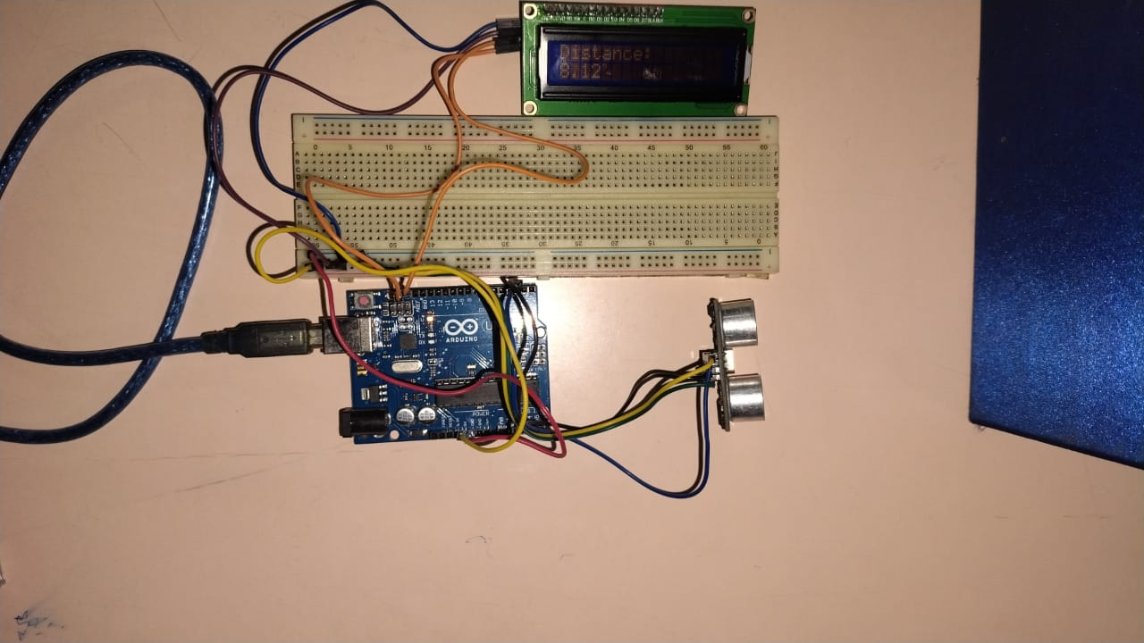

6. Testing and Calibration

Sensor Validation: Compare the sensor readings with a standard ruler or measuring tape to verify accuracy.

LCD Display: Ensure correct I2C address is used and the LCD shows stable readings without flicker or delay.

7. Applications and Future Enhancements
- Applications:
  - Robotic Obstacle Detection
  - Parking Assist Systems
  - Industrial Object Detection and Sorting
- Future Enhancements:
  - Use of servo motors to act upon specific distance ranges.
  - Data logging with SD card or cloud.
  - Bluetooth or Wi-Fi module to monitor distance remotely.

8. Conclusion
This project provides a simple and effective method for measuring distances using the HC-SR04 ultrasonic sensor and Arduino Uno. The integration of an I2C 16x2 LCD allows for clear, real-time display of the measurements. The setup is ideal for educational purposes, prototyping, and small-scale automation tasks.

